World War Two
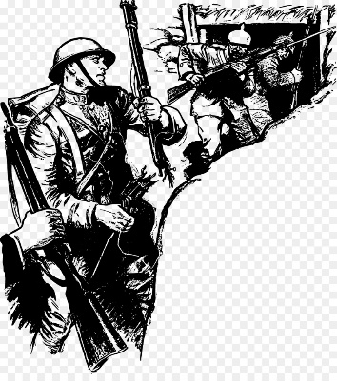
- Around 64 million people died in World War Two (That is more than the population of the UK!)

- Hitler’s plan to invade Britain was called Operation Sealion.

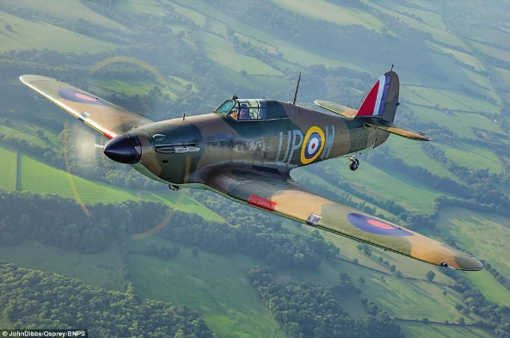
- The RAF had a fighter plane called the Hurricane. They used it to destroy German Bombers before they could attack British towns and cities. (My Great Great Uncle Jim was in the RAF!)

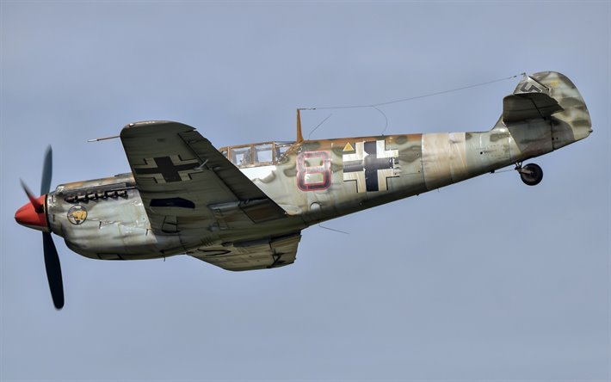
- The German Bombers most famous fighter aeroplane was the Messerschmitt.

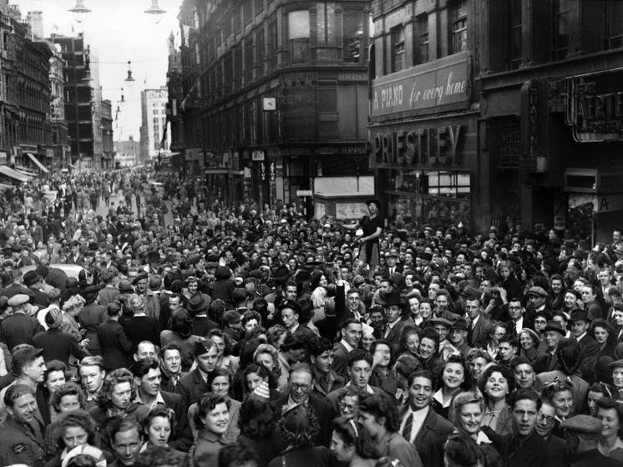

- World War Two ended in Europe on 8th May 1945-this is also known as VE Day (Victory in Europe day.)

